# ONLINE AGROSALES

# A PROJECT REPORT

***Submitted by***

**SIVA PRAKASH S (1612097)**

**VISHNU PRAKASH K(1612122)**

**VISHNU HARICHANDRAN H(172402)**

**VIGNESHWARAN K(1612118)**

***in partial fulfillment for the award of the degree of***

**BACHELOR OF ENGINEERING**

**IN**

**COMPUTER SCIENCE AND ENGINEERING**



# NATIONAL ENGINEERING COLLEGE

**(An Autonomous Institution, Affiliated to Anna University, Chennai) K.R.NAGAR, KOVILPATTI: 628 503**

**ANNA UNIVERSITY, CHENNAI:600 025**

**MAR 2020**

ANNA UNIVERSITY : CHENNAI 600 025

BONAFIDE CERTIFICATE

Certified that this project report “**ONLINE AGROSALES ”** is the bonafide work of **“ SIVA PRAKASH(REGISTER.NO:1612097), VISHNU PRAKASH K (REGISTER NO: 1612122), VISHNU HARICHANDRAN H (REGISTER NO: 172402) AND VIGNESHWARAN K(REGISTER NO:1612118)”** who carried out the project work under my supervision.

# SIGNATURE SIGNATURE

Dr.V.GOMATHI ., M.Tech., PhD., T.BHUVANESWARI.,M.E.,

# HEAD OF THE DEPARTMENT SUPERVISOR

Computer science and engineering Computer science and engineering National Engineering College National Engineering College (An Autonomous Institution, (An Autonomous Institution, Affiliated To Anna University, Chennai) Affiliated To Anna University, Chennai)

K.R.Nagar, Kovilpatti: 628 503 K.R.Nagar, Kovilpatti: 628 503

Submitted to the viva-voce examination held at **NATIONAL ENGINEERING COLLEGE, K.R NAGAR, KOVILPATTI** on ……………

# Internal Examiner External Examiner

**ABSTRACT**

Technological importance plays an essential role in various fields, especially in agriculture. Agricultural advancements haven't been much for the past few years due to a lack of Agriculture knowledge and technological improvements. e-Agriculture is a platform for supporting the marketing of agricultural products and also cutting off unnecessary losses in transit. The technique implemented here is to minimize the role of the middle man and improve the overall profit for both farmers and vendors alike in e-Commerce. Previous profits of farmers indicate that a portion of their yield is lost via transit of middle man. The main aim of this paper is to reach farmers for their awareness, usage, and efficiency in agriculture.

**TABLE OF CONTENTS**

|  |  |  |
| --- | --- | --- |
| **S.NO** | **TOPIC** | **PAGE NUMBER** |
|  | ABSTRACT | 3 |
|  | TABLE OF CONTENTS | 4 |
| 1 | **CHAPTER I** |  |
|  | INTRODUCTION | 6 |
| 1.1 | OVERVIEW | 6 |
| 1.2 | OBJECTIVE | 6 |
| 1.3 | FACE DETECTION | 6 |
| 1.4 | FACE TRACKING | 7 |
| 2 | **CHAPTER II** |  |
|  | LITERATURE REVIEW | 8 |
| 3 | **CHAPTER III** | 11 |
|  | PROPOSED SYSTEM | 12 |
| 3.1 | REFERENCE FRAME SELECTION | 13 |
| 3.2 | FRAME LENGTH SELECTION | 13 |
| 3.3 | MOVING OBJECT DETECTION | 13 |
| 3.3.1 | FRAME DIFFERENCE METHOD | 13 |
| 3.3.2 | APPROXIMATE MEDIAN METHOD | 14 |
| 3.3.3 | MODIFIED FRAME DIFFERENCE | 14 |
| 3.4 | DESIGN METHODOLOGY | 15 |
| 3.5 | REQUIREMENTS | 17 |
| 3.5.1 | CAMERA | 17 |
| 3.5.2 | PYTHON MODULES | 17 |
| 3.5.2.1 | OPENCV | 17 |
| 3.5.2.4 | NUMPY | 18 |
| 3.5.2.5 | TENSORFLOW | 18 |

|  |  |  |
| --- | --- | --- |
| 3.5.2.6 | FACE DETECTION | 19 |
| 3.6 | IMPLEMENTATION | 20 |
| 4 | **CHAPTER IV** |  |
|  | RESULT | 23 |
| 5 | **CHAPTER V** |  |
|  | FACE DETECTION AND TRACKING APPROACHES | 27 |
| 6 | **CHAPTER VI** |  |
| 6.1 | CONCLUSION | 29 |
| 6.2 | REFERENCES | 30 |

**CHAPTER I**

**INTRODUCTION**

# OVERVIEW

# Agriculture is the backbone of India, saying this, many of the agriculturists face so many problems in the agriculture that includes improper value for the products they produce and thereare no proper discussion platforms where they could discuss or clarify their doubts regarding the agriculture. Thus here a new method is tried to find a solution to make the farmers to sell their products and also to discuss the issues. An auction websitewith all the other kinds of features such as a chat room and discussion forum would satisfy the farmer needs. Unlike the normal website; this auction model website is hosted in the Amazon elastic cloud compute server which could be a reliable environment for this kind of system [1]. The cloud servers are not only reliable but also provide so many advantages such as scalability and cost effectiveness [6].There are many applications developed and hosted in the Amazon web services [2-3]English Auction model is of the forward auction type where a single item is considered for sale [4-5]. Usually here, the bidding moves from low price to progressively high price. The auction is closed when higher bid for the item is made. In this model, the seller sets a margin price. No item is sold below the margin price. The auction is aborted if there is a bid lesser than the margin price. The Dutch Auction is an auction model where the share price of the bidding item lowered to a level where there are enough bids to sell all the shares.Vickery Auction was invented by the Canadian Nobellaureate economist William Vickrey. Here the auction is carried out such a way that the buyer or seller pays the second best price for the bidding item. This auction serves the potential buyer to offer a value to the item in his or her own judgment. Next auction type which resembles gambling is the Reserve auction. In is auction type, many sellers offer their items and compete for the bidding. In this model the buyer can accept any bid, by paying for every bid he is placing or can reject all the items. In this model, there is a change for the buyer to lose money or will not get anything back in return. The auctioneer will make money by offering of bids and collecting the amount for the item bided. In First sealed price auction model, the bidder can bid only once and the bidder who bids the highest price will win. This model is different from the English model in such way that, here the bids are closed and this system is open-bidding type.

# OBJECTIVE

# Make farmers get the best price for their products. Eliminate middlemen so that the farmers get the total benefit. Farmers can choose their customers who quote more i.e. they can choosewhom to sell their products on the basis of the price the customers are ready to pay.Farmers get to know the demand in the market of the products they are selling.This will help them to concentrate on the crops which is in high demand.The Online Bidding Application helps the farmers meet the customers directly.The winner of the bid and the seller of that product get an email as notification about the confirmation of the product. Discussion forum is available for the buyers and sellers to discuss about the products. Feedback forum is provided to the winner of the bid so that his feedback can help other buyers to decide for buying of the product from that particular seller.

# CHAPTER II LITERATURE REVIEW

In case of auction the first thing comes in mind how to sell a product. Simply it means in auction the seller waits for the high number of prices and waits for the bidder who remains active till the last of the auction process. There are various types of bidding a product. To overcome a traditional auction process, this online auction process had been used which is detailed in[1].Secondly, a various types of auctions had been described such as English auction(ascending bid auction),the Dutch auction (descending-bid auction), the first-price sealed-bid auction, and the Vickrey auction (second-price sealed-bid auction) as explained in [2]. It also described the steps of how auction will be carried out and what information should be carried on.The internet auction is the most simple to use for maintaining the data then the traditional auction which is to be carried on the paper.And most of the auction hasbeen learned by the economists for the understanding purpose to study their properties and how it works.In [3], it describes how the auction is carried out on the internet and what the information is provided before the auction and after the auction process.It also describes auction such as user agents and mobile agents. User agent mostly done on the user’s PC with the help of the some services or some expert advices while mobile agent deals with the execution of program through remote base server. In addition to this the auction time is provided with the help of auction date and the last date of ending the auction.Earlier auction products were like electrical equipments,etc. But now Agricultural Product can also been auctioned. First product was Tea Auction.Now-a-days auctioning process has been became a competitive in the market. The auction can be done from anywhere in the world at any time and anyone can auction the products which is detailed in [4].In additional to single item auctioning, it also consists of multi-item auctioning where n number of items are auctioned simultaneously as described in[6]. In multi-item auction it provides more opportunities for online auction market in large market over the world with higher efficiency.This multi-item auction has came into existence because now-a-days very small markets does the auctioning of similar items which results into less efficiency.Multi-attribute auctions consists of practicalandtheoreticalproblems which has been detailed in[7].In case of practical problems the users should know the product and market characteristics.With help of this term the auction is also referred as the common value based. Sometimes it becomes difficult to arrange the behaviour of the goods which may result in difficult for the analysisof the product. The analysis of the product is also done in case of reverse auction. Because of this the economist’stheory and experimentswhich is used for the developmental testing.Along with traditional auction the internet auction has been more popular. For the internet auction there are various security requirements. Firstly the seller should know whether he/she is going to post a product in large scale or not. Then the user who isinterested should register first and then access the site. The security requirement is used to know whether the site is used by the registered person. Therefore an administrator is used as a trusted third party to keep the records of all the procedures happening which has been explained in[8].Auction application is carried with the help of auction rules which defines the auction schedule, templates for creating the auction and the individual auction rules for the individual auction product.As e-commerce auction is used widely it has featured many security protocols[9]. It has described some security properties such as atomicity of the transaction, weak private keys and weak public keys

In case of voting or bidding the product it consists of much work on the verification of the users and the product which is to be handled in the area of privacy.As auction is defined as mobile agents which deals with the execution of program on the remote server database. The mobile agents in electronic auction is slightly different as described in[10]. The mobile agents in electronic auction first visits the site of auction and then the user may actively participate in auction process. If the user is disconnected for some time then in behalf of user it can participate for a specific time period. After registering it as server, the mobile agents itself creates its own user profile

# CHAPTER III PROPOSED SYSTEM

The idea is to develop an online bidding application that would help the farmers and the customers contact each other directly and do the business. This would include a cloud platform that would store the data of the registered users(farmers and customers) .The cloud platform will be a live cloud (Platform as a Service).The application will include membership module for loyal farmers (registered farmers) to participate in it. The online forum will help the customers interact with each other.Farmers get to know the actual demand in the market through the requests that customerspost on the application. This idea comes under Recent trends in IT and hence would require MVC (Model View Controller)design pattern as the core technique to build it.The application would help the farmers bid the price and the highest bidder(customer)will get away with the product.This application will be made available to anyone across the globe via accessing the URL

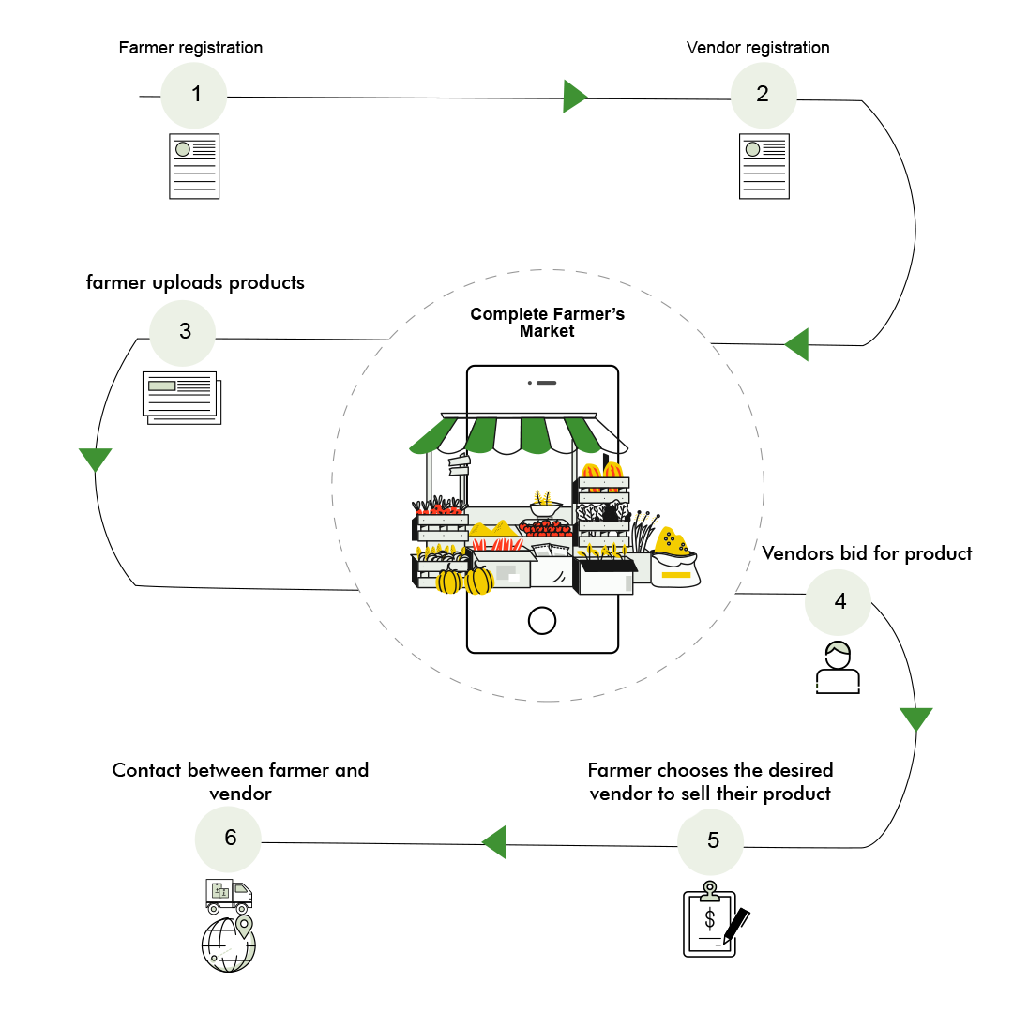

# CHAPTER IV REQUIREMENTS

# Software Requirements:

# Text Editor- Sublime text

# Internet Browser – Google Chrome/Microsoft Edge/Firefox etc

# Server – 000webhostapp.com

# Front-End

Front-end web development is the practice of converting data to a graphical interface, through the use of HTML, CSS, and JavaScript, so that users can view and interact with that data.



**Html:**

Hyper Text Markup Language (HTML) is the backbone of any website development process, without which a web page doesn't exist. Hypertext means that text has links, termed hyperlinks, embedded in it. When a user clicks on a word or a phrase that has a hyperlink, it will bring another web-page. A markup language indicates text can be turned into images, tables, links, and other representations. It is the HTML code that provides an overall framework of how the site will look.

**CSS:**

Cascading Style Sheets (CSS) controls the presentation aspect of the site and allows your site to have its own unique look. It does this by maintaining style sheets which sit on top of other style rules and are triggered based on other inputs, such as device screen size and resolution.

**Javascript:**

JavaScript is an event-based imperative programming language (as opposed to HTML's declarative language model) that is used to transform a static HTML page into a dynamic interface. JavaScript code can use the [Document Object Model] (DOM), provided by the HTML standard, to manipulate a web page in response to events, like user input.

**Bootstrap:**

Bootstrap is a free and open-source CSS framework directed at responsive, mobile-first front-end web development. It contains CSS- and (optionally) JavaScript-based design templates for typography, forms, buttons, navigation, and other interface components.

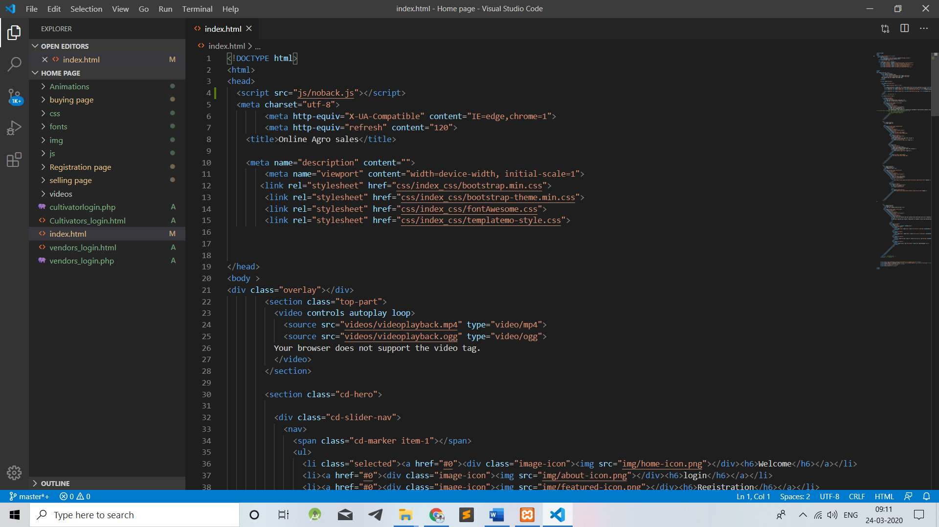

# Back-End

xxxxxx



xxxxxx

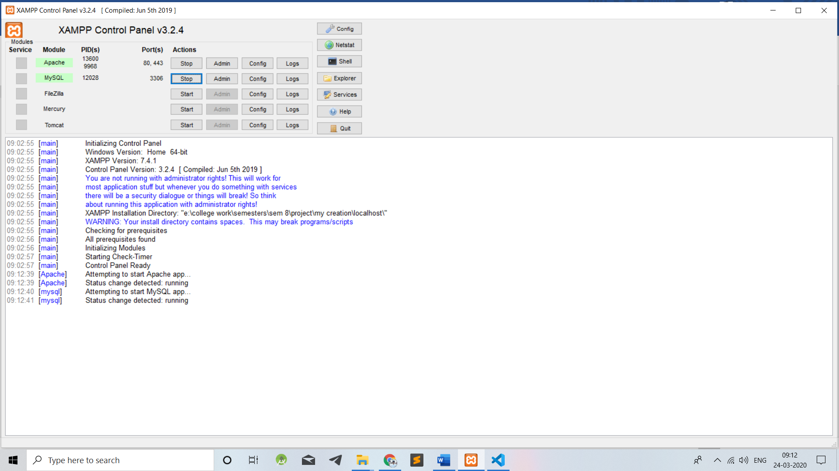

# PHPMyadmin

Xxxxx



# Integration of front and back end

xxxxxx

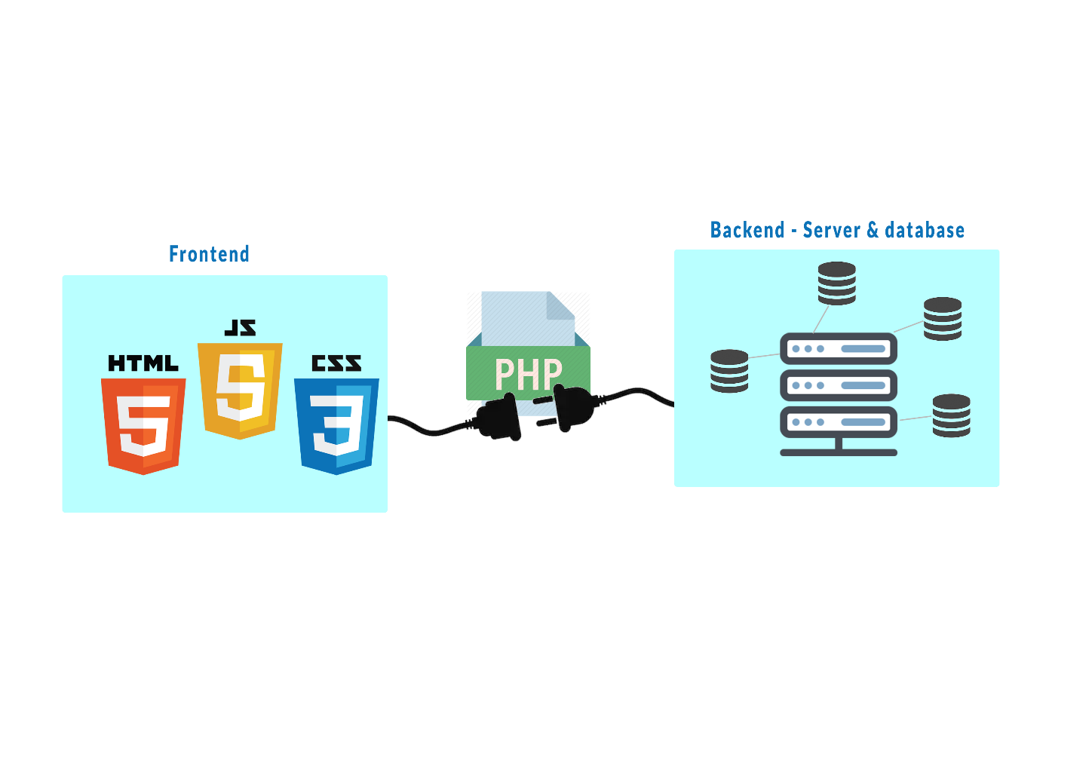

# REQUIREMENTS

# Text Editor:

# Xxxxx

# Internet Browser:

# Xxxxx

# Server:

# Xxxxx

* + 1. **WORKFLOW**

xxxxx

.

# IMPLEMENTATION

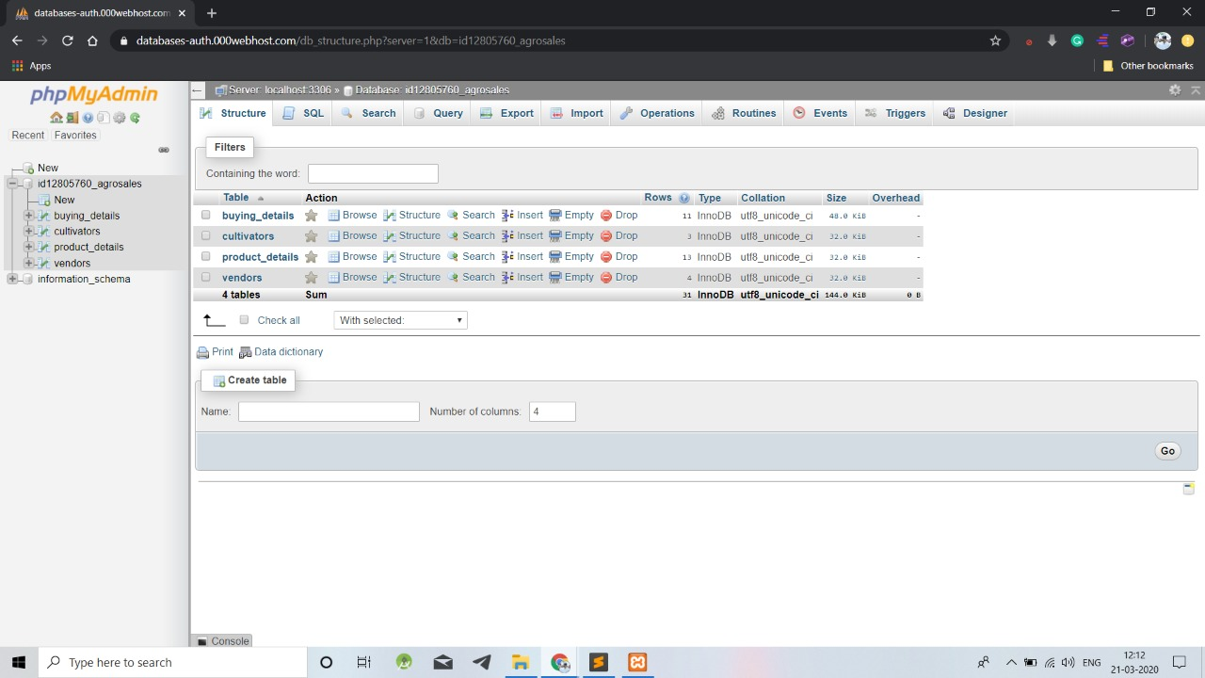

# Fig.no:3.4

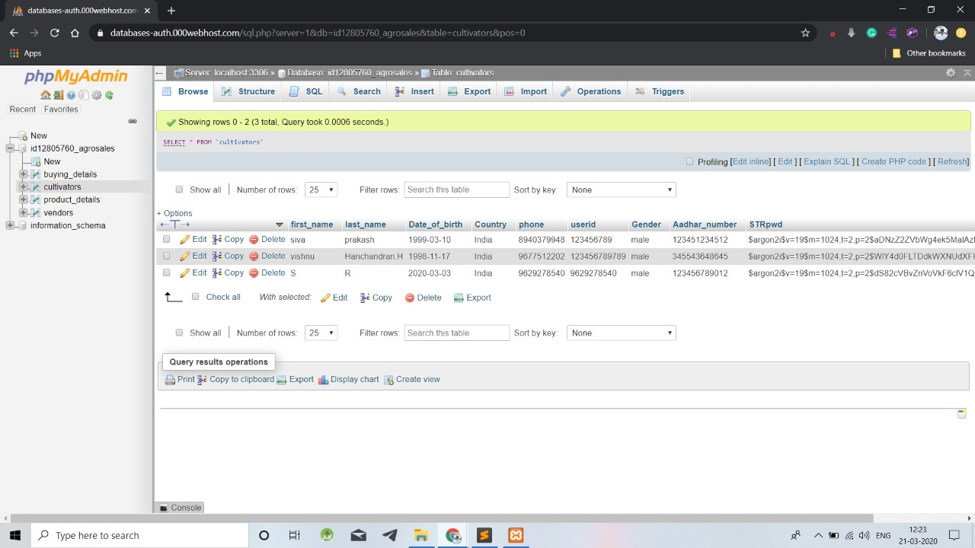

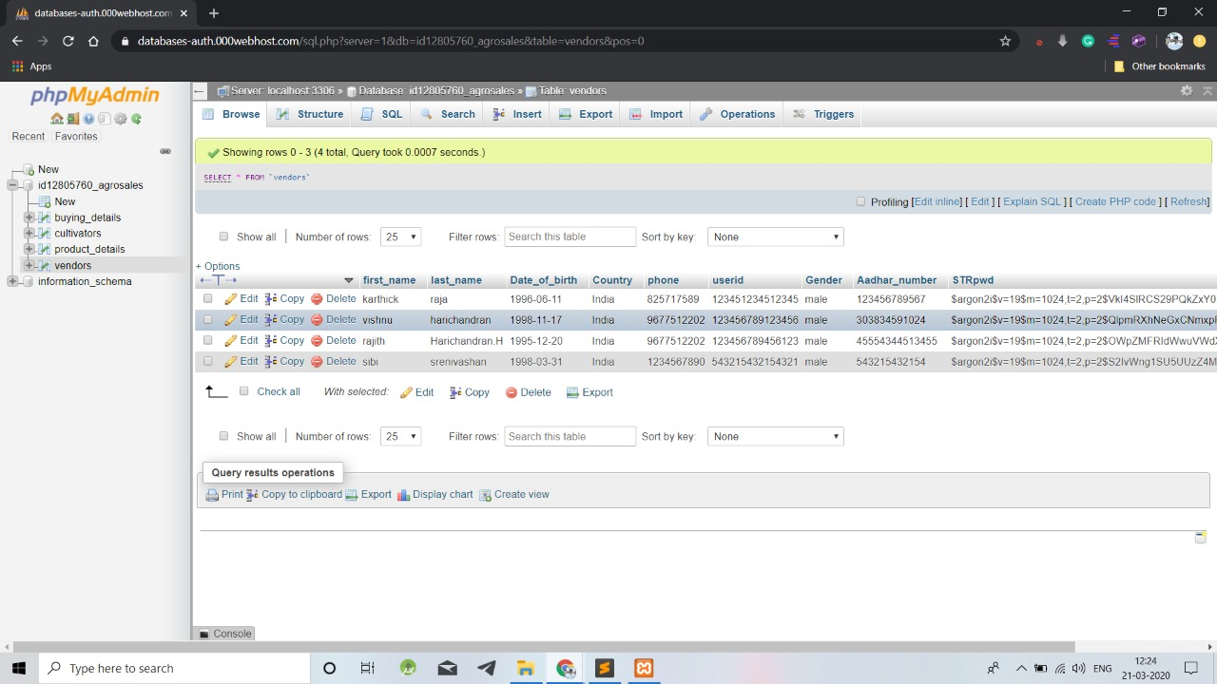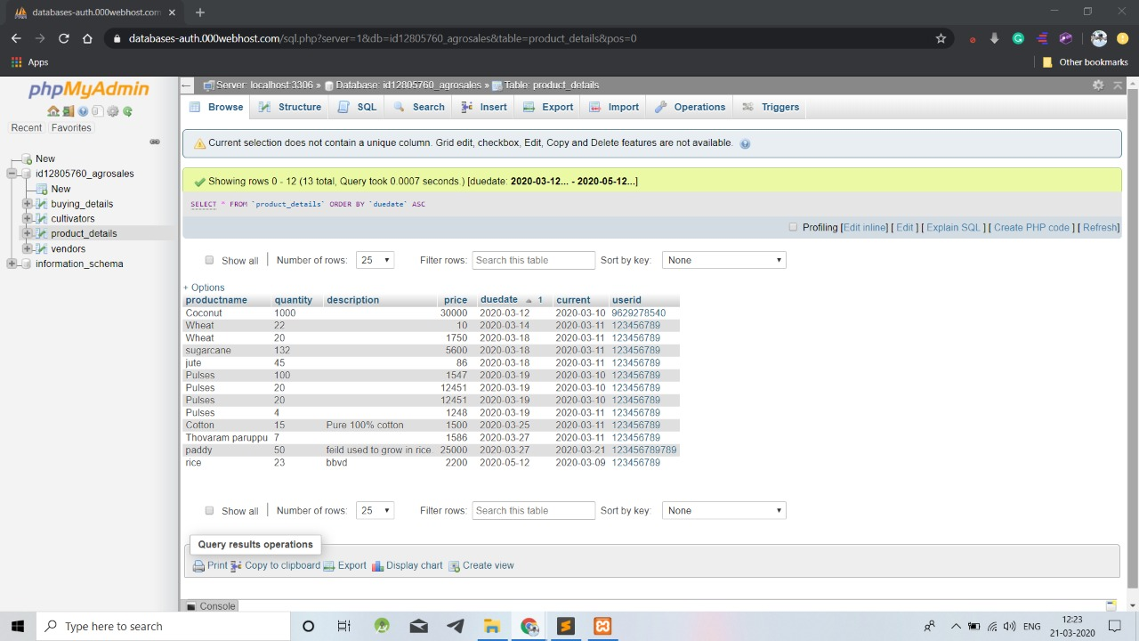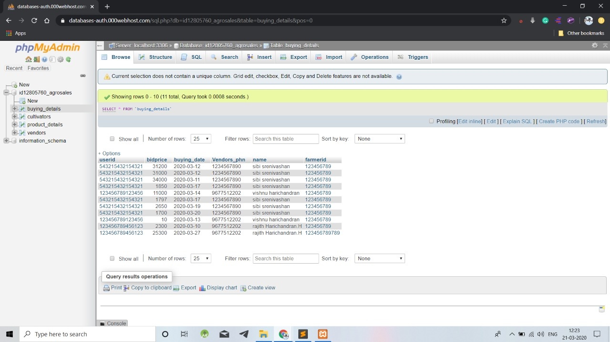

# Fig.no:3.5

* + 1. **Password Hashing**

**XXXXX**

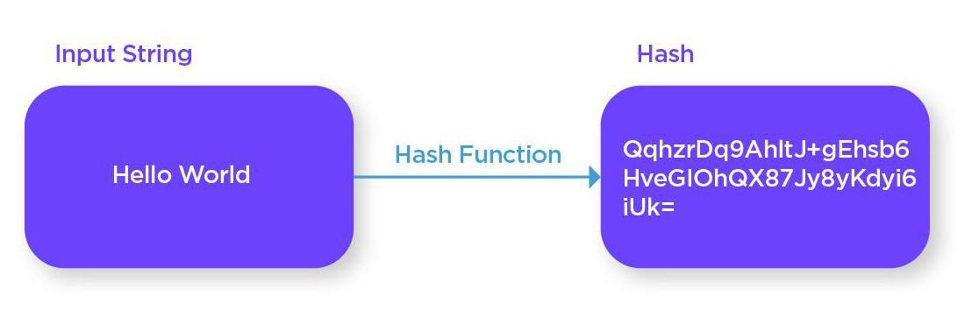

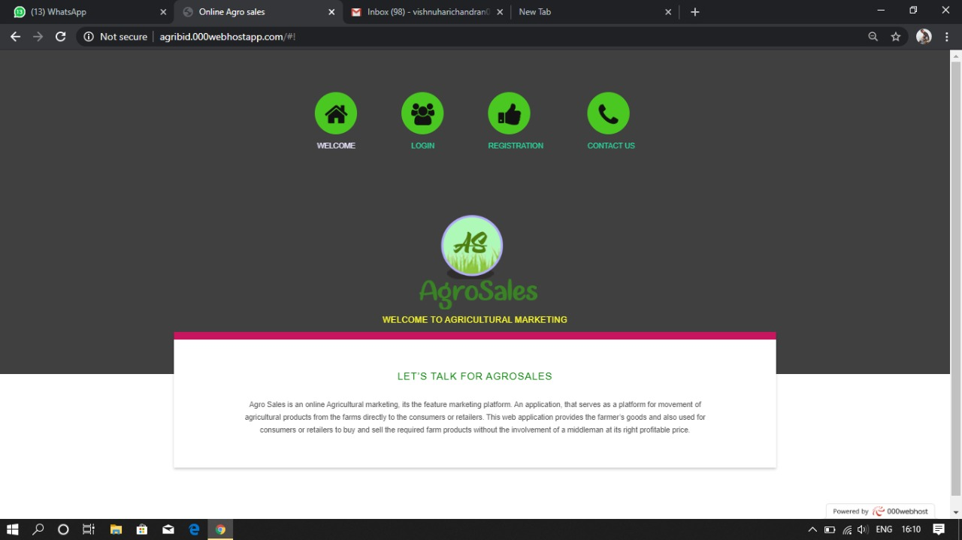

# Fig:3.7 Frame by frame

**CHAPTER IV**

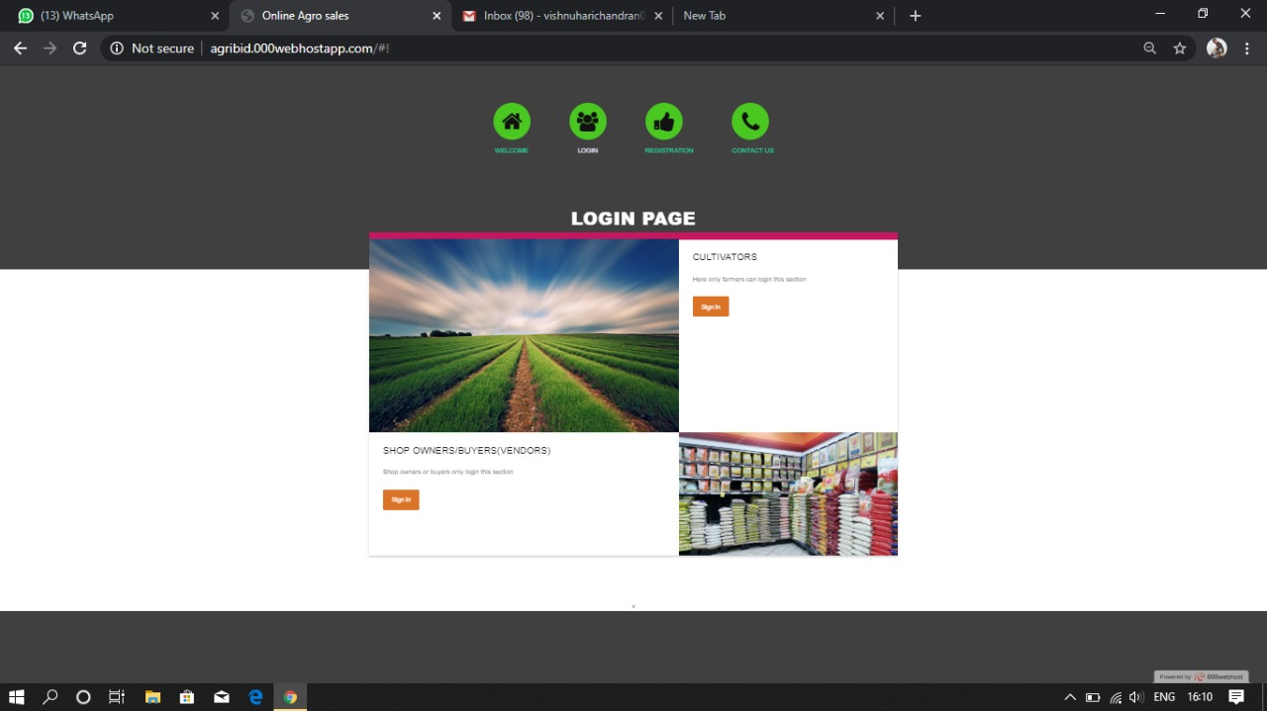

**Fig.no:4.1**

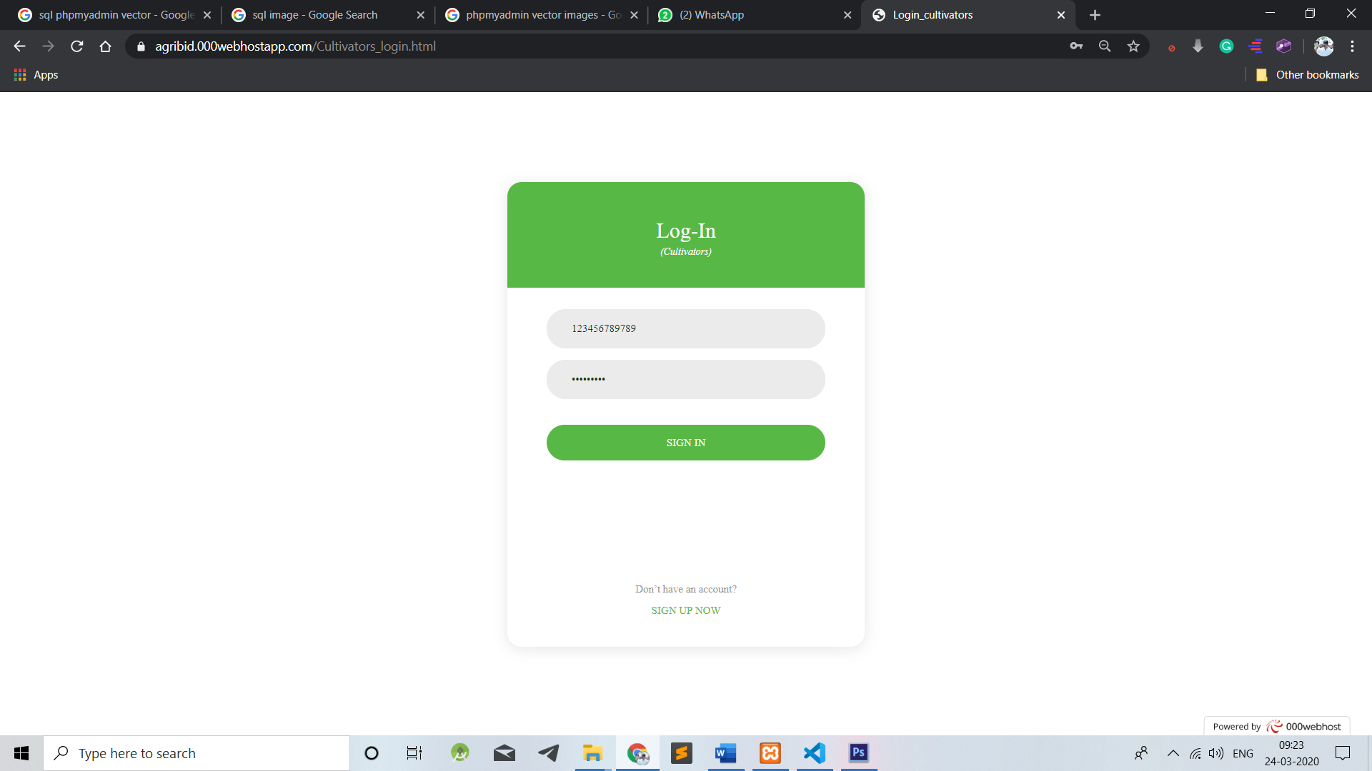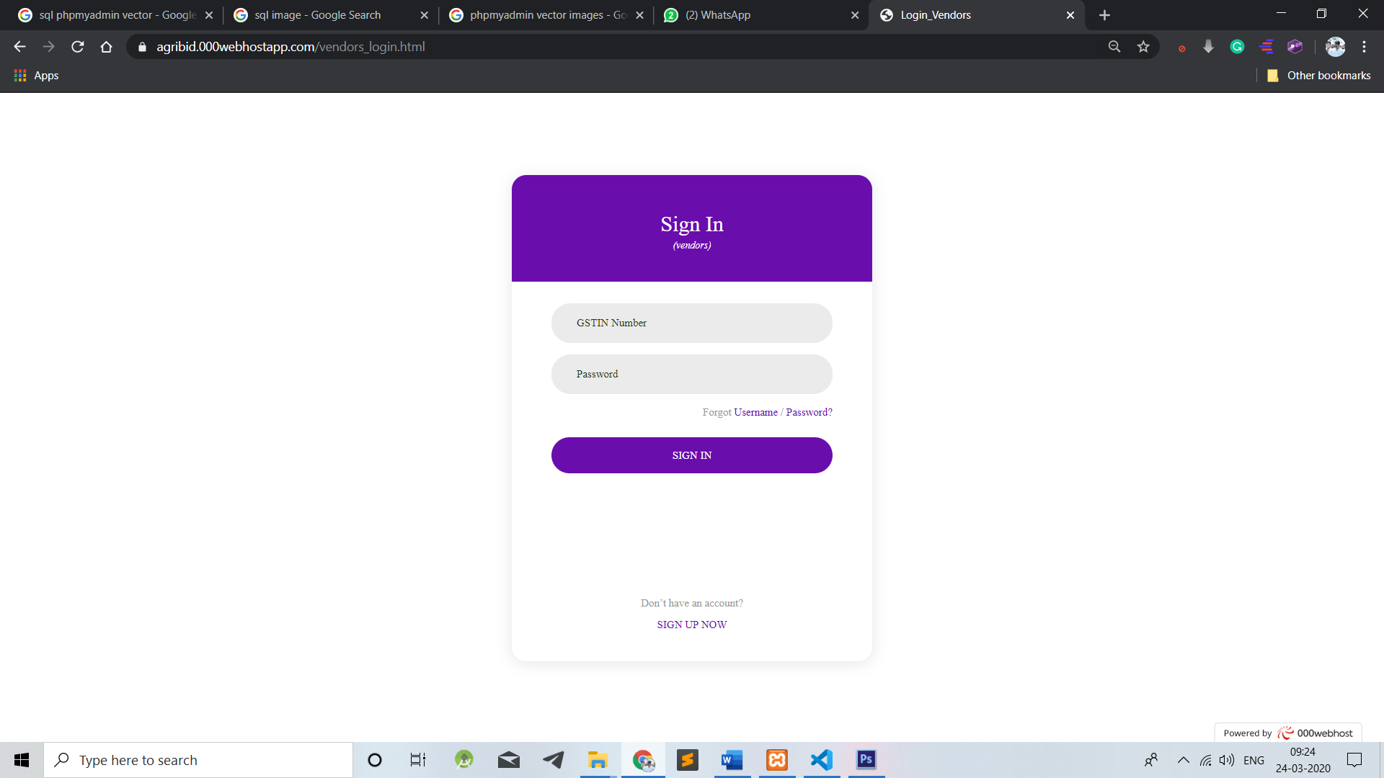

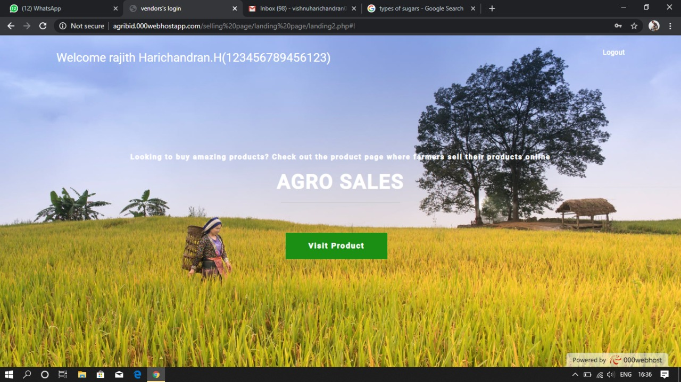

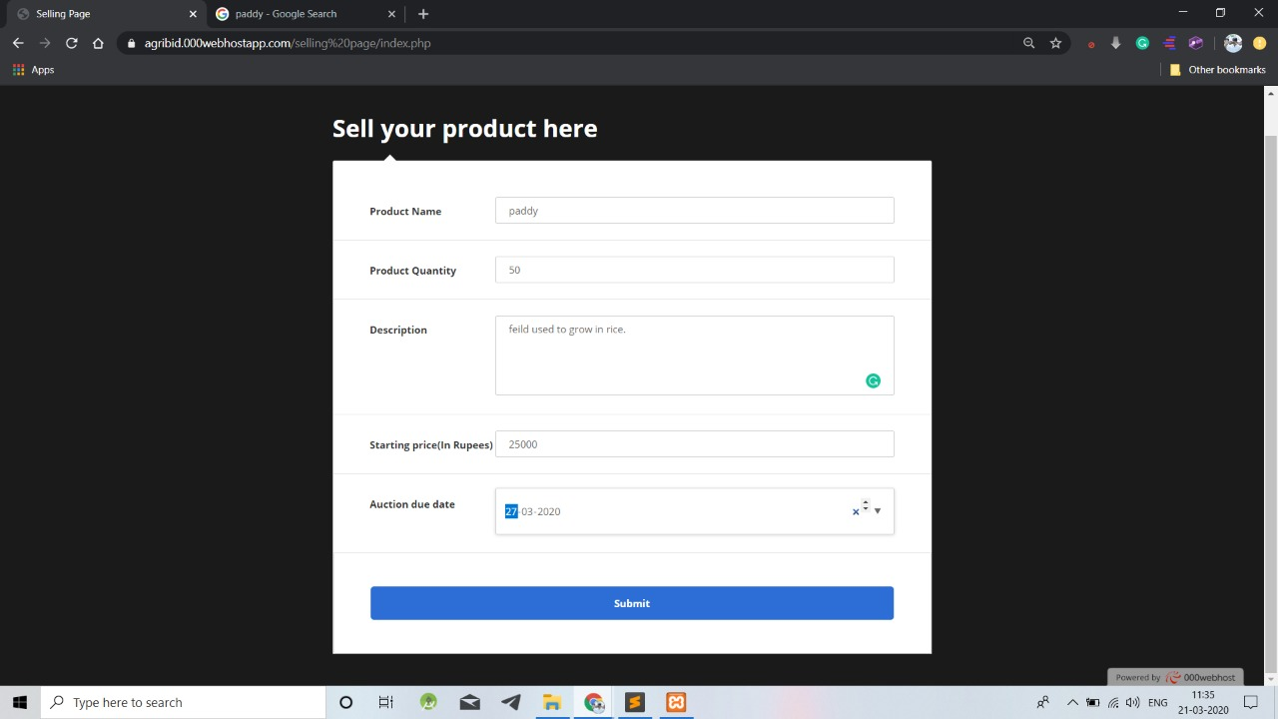

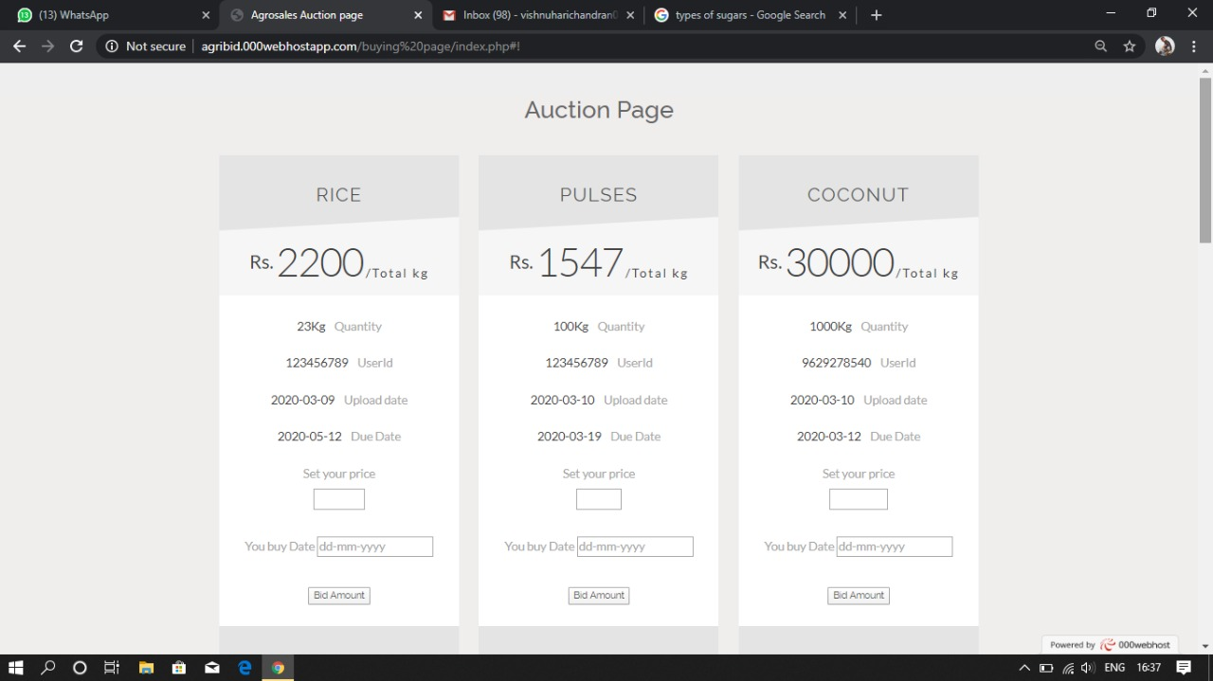

# Figure 4.2 Input Image

**Figure 4.3 Recognized Image**

**CHAPTER V**

**RESULT**

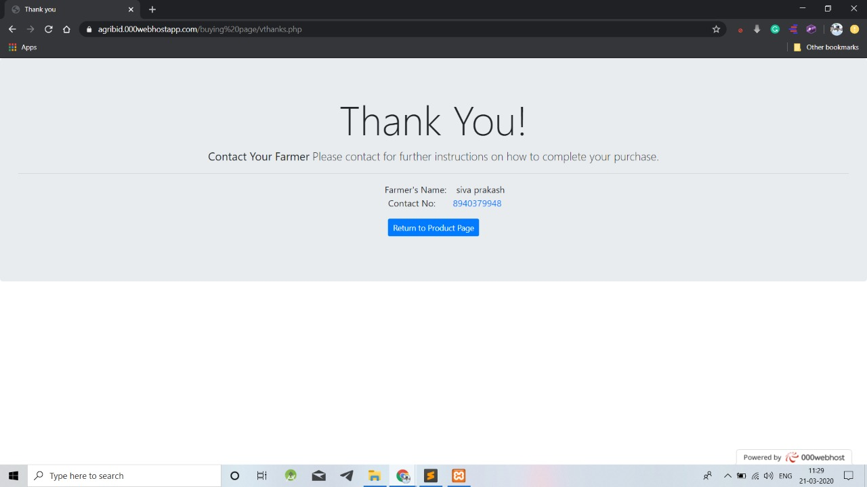

XXXXXX

Some contents have been added by siva

# CHAPTER VI

* 1. **CONCLUSION**

An Online Bidding application deployed on CloudPlatform as a Service(PaaS) for sales of agricultural products and deploys end to end live application feature.The project is completely related to the farmers and the customers. It would benefit both of them equally. Farmers will get the complete price of their hard work. Customers need to pay only the price of the product and not the intermediate charges which are applied due to the involvement of the middlemen.This application completely eliminates middlemen hence it’s a direct communication platform between thefarmers and the customers.This web application not only provides the highest price for the farmers but also it possess many additional features which serve the application as the most easy, reliable and user friendly application which would in-turn help the users who are new to this computer era. In addition to all these facilities, cloud technology is used for hosting with which the website runs at the maximum speed without any interruption.

**REFERENCES**

[1]CassadyR.Jr. “Auctions and auctioneering” University of California.

[2]Bajari, Patrick, Ali Hortacsu (2004). "Economic Insights from Internet Auctions" Journal of Economic Literature, Vol. XLII No. 2: 457-86.

[3]Lucking-Reiley, David (2000), “Auctions on the Internet: What’s Being Auctioned, and How?”Journal of Industrial Economics, 48(3): 227–52.

[4]Milgrom, Paul R. and Robert J. Weber (1982), “A Theory of Auctions and Competitive Bidding,” Econometrica, 50(5): 1089–1122.

[5]Engelbrecht And Wiggans R. “Auctions and BiddingModels a survey” Cowles foundation and discussion paer no.486R.

[6]V. Bansal and R Garg 2001 “Efficiency and price discovery in multi-item auction” ACM SIGecom Exchange,Issue (Winter 2001)26-32.

[7]M Bichler 2000 “An experimental analysis of multi attribute auctions” Decision support system 29

[8]M Kumar and S I Feldman 1998 “The Internet auction”proc. of the Usenix Workshop on electronic commerce(Aug 1998).

[9]S Subramanian 1998 “Design and verification of secure electronic auction”proceedings of IEEE Symposium on reliable distributed system

[10]T Sandholm and Q Huai 2000. Nomad:”Mobile agent system for an internet based auction” IEEE Internet Computing 4.